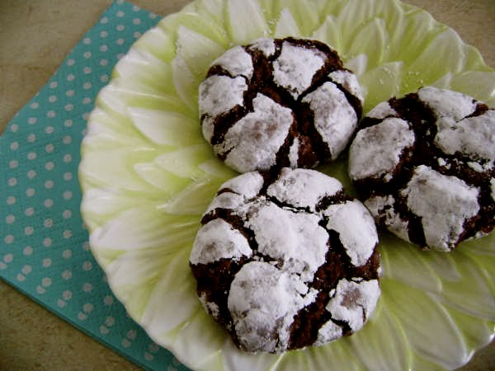
ingredients:
2 cups sugar
3/4 cup vegetable oil
3/4 cup hershey's cocoa powder
4 eggs
2 tsp vanilla extract
2 1/3 cups all-purpose flour
2 tsp baking powder
1/2 tsp salt
powdered sugar
directions:
in a large mixing bowl, combine sugar & oil. add cocoa; blend well. beat in eggs and vanilla. combine flour, baking powder & salt; add to cocoa mixture blending well. cover; chill at least 6 hours. heat oven to 350. shape dough into 1 inch balls. roll in powdered sugar. place 2 inches apart on greased cookie sheet. bake 12 to 14 minutes or until almost no indentation remains when touched. remove from cookie sheet; cool on wire rack. makes 4 dozen.

