The Best Gluten-Free Pizza

From Pizza and Cookies Go Gluten-Free
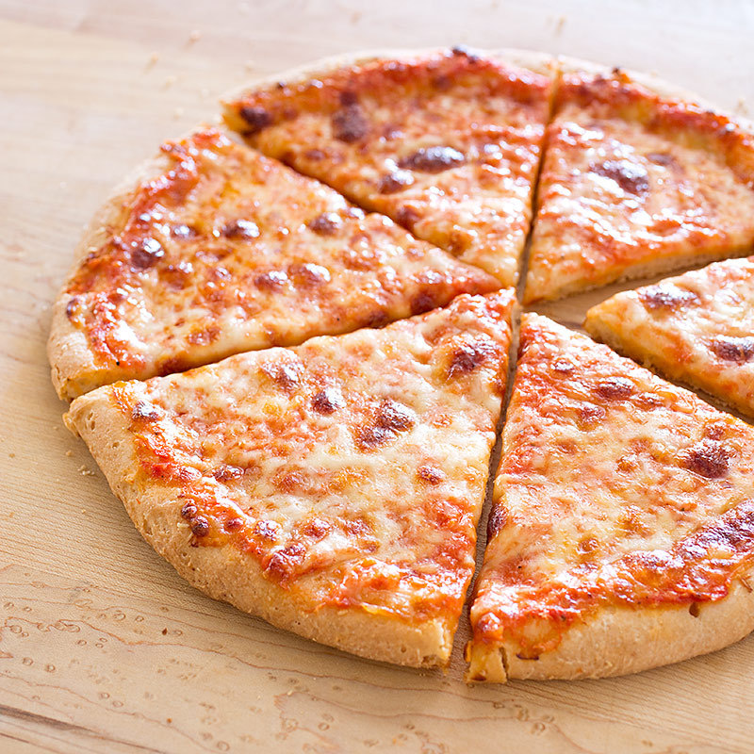
- Save
- Email
- Share
- Tweet
- Pin

Why This Recipe Works
Achieving a crispy crust and a tender interior on a gluten-free pizza was no easy feat. First, we developed a gluten-free flour blend that mimicked many of the properties of wheat flour: white rice flour for starch, brown rice flour for whe...
Read More
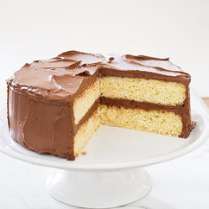
Cooking SchoolGluten-Free Baking
Learn More

More Like This
- 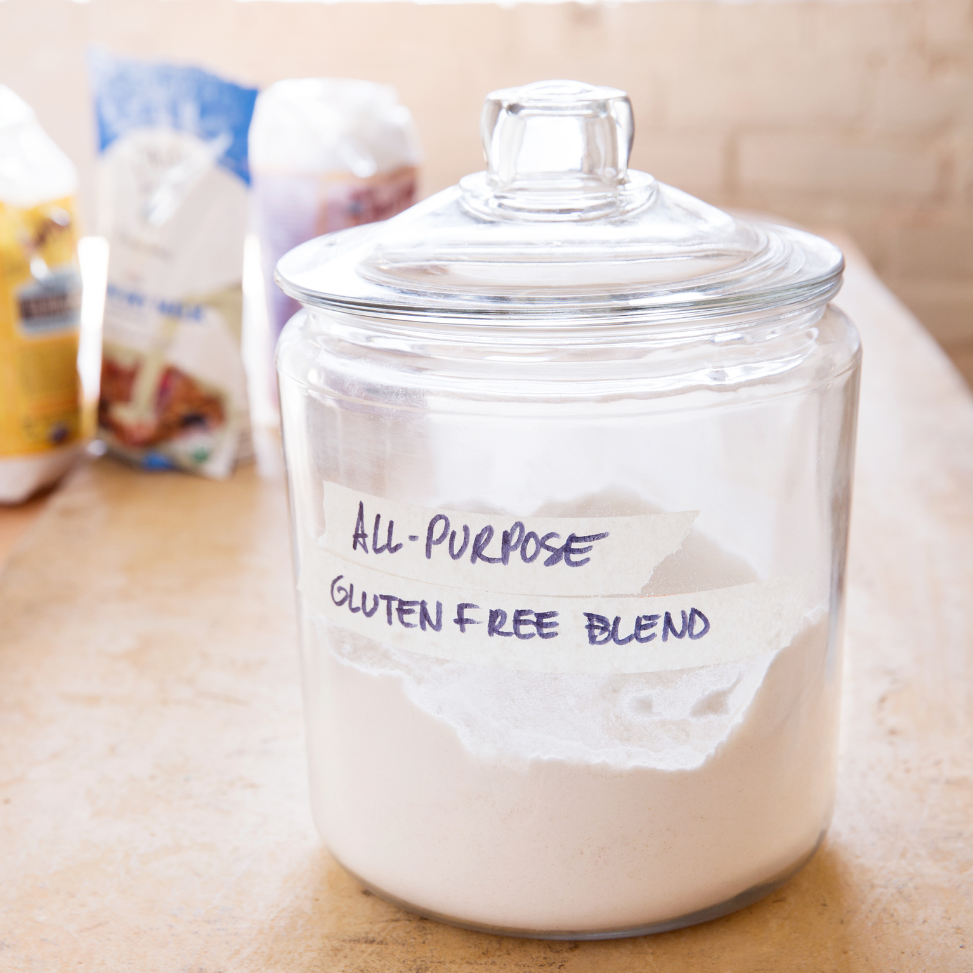
RecipeAmerica's Test Kitchen All-Purpose Gluten-Free Flour Blend

- 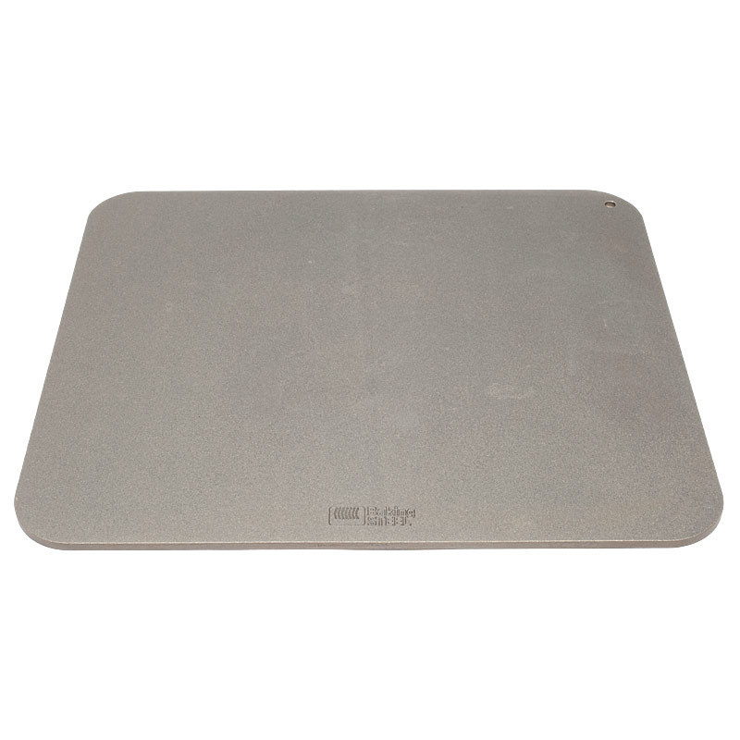
Equipment ReviewBaking Steel

Ingredients

Crust
- 16
ounces (3 1/3 cups plus 1/4 cup) ATK All-Purpose Gluten-Free Flour Blend, (see related content)
- 2 1/2
ounces (1/2 cup plus 1 tablespoon) almond flour
- 1 1/2
tablespoons powdered psyllium husk
- 2 1/2
teaspoons baking powder
- 2
teaspoons salt
- 1
teaspoon instant or rapid-rise yeast
- 2 1/2
cups warm water, (100 degrees)
- 1/4
cup vegetable oil
- Vegetable oil spray

Sauce
- 1
(28-ounce) can whole peeled tomatoes, drained
- 1
tablespoon extra-virgin olive oil
- 1
teaspoon red wine vinegar
- 1
garlic clove, minced
- 1
teaspoon dried oregano
- 1/2
teaspoon salt
- 1/4
teaspoon pepper

Cheese
- 1
ounce Parmesan cheese, grated fine (1/2 cup)
- 8
ounces whole-milk mozzarella cheese, shredded (2 cups)

Instructions

Makes Two 12-inch Pizzas
NOTE FROM THE TEST KITCHEN This recipe requires letting the dough rise for 1 1/2 hours and prebaking the crusts for about 45 minutes before topping and baking. If you don’t have almond flour, you can process 2 1/2 ounces of blanched almonds in a food processor until finely ground, about 30 seconds. Psyllium husk is available at health food stores. You can substitute 16 ounces (2 2/3 cups plus 1/4 cup) King Arthur Gluten-Free Multi-Purpose Flour or 16 ounces (2 2/3 cup plus 1/2 cup) Bob’s Red Mill GF All-Purpose Baking Flour for the America’s Test Kitchen Gluten-Free Flour Blend (see related content). Note that pizza crust made with King Arthur will be slightly denser and not as chewy, and pizza crust made with Bob’s Red Mill will be thicker and more airy and will have a distinct bean flavor.
- 1. FOR THE CRUST: Using stand mixer fitted with paddle, mix flour blend, almond flour, psyllium, baking powder, salt, and yeast on low speed until combined. Slowly add warm water and oil in steady stream until incorporated. Increase speed to medium and beat until dough is sticky and uniform, about 6 minutes. (Dough will resemble thick batter.)
2. Remove bowl from mixer, cover with plastic wrap, and let stand until inside of dough is bubbly (use spoon to peer inside dough), about 1 1/2 hours. (Dough will puff slightly but will not rise.)
3. Adjust oven racks to middle and lower positions. Line 2 rimmed baking sheets with parchment paper and spray liberally with oil spray. Transfer half of dough to center of 1 prepared sheet. Using oil-sprayed rubber spatula, spread dough into 8-inch circle. Spray top of dough with oil spray, cover with large sheet of plastic, and, using your hands, press out dough to 11 1/2-inch round, about 1/4 inch thick, leaving outer 1/4 inch slightly thicker than center; discard plastic. Repeat with remaining dough and second prepared sheet.
4. Place prepared sheets in oven and heat oven to 325 degrees. Bake dough until firm to touch, golden brown on underside, and just beginning to brown on top, 45 to 50 minutes, switching and rotating sheets halfway through baking. Transfer crusts to wire rack and let cool.
5. FOR THE SAUCE: Process all ingredients in food processor until smooth, about 30 seconds. Transfer to bowl and refrigerate until ready to use.
6. One hour before baking pizza, adjust oven rack to upper-middle position, set baking stone on rack, and heat oven to 500 degrees.
7. Transfer 1 parbaked crust to pizza peel. Using back of spoon or ladle, spread 1/2 cup tomato sauce in thin layer over surface of crust, leaving 1/4-inch border around edge. Sprinkle 1/4 cup Parmesan evenly over sauce, followed by 1 cup mozzarella. Carefully slide crust onto stone and bake until crust is well browned and cheese is bubbly and beginning to brown, 10 to 12 minutes. Transfer pizza to wire rack and let cool for 5 minutes before slicing and serving. Repeat with second crust, 1/2 cup tomato sauce (you will have extra sauce), remaining 1/4 cup Parmesan, and remaining 1 cup mozzarella.
TO MAKE AHEAD: Extra sauce can be refrigerated for up to 1 week or frozen for up to 1 month. Parbaked and cooled crusts can sit at room temperature for up to 4 hours. Completely cooled crusts can be wrapped with plastic wrap and then aluminum foil and frozen for up to 2 weeks. Frozen crusts can be topped and baked as directed without thawing.

Techniques

A Gluten-Free Crust That Doesn’t Fall Flat
With psyllium husk and plenty of water, our dough has the structure and elasticity that others lack.
OUR CRUST: Airy and tender
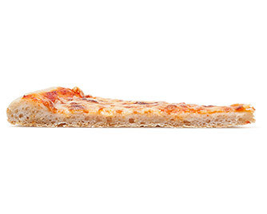
TYPICAL GLUTEN-FREE CRUST: Dense and rubbery
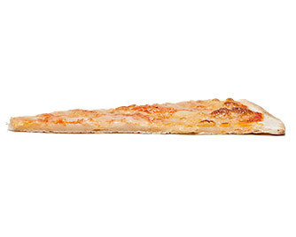

Forget the Dough: Make a Batter
Most traditional pizza dough requires a 60 percent hydration level, but gluten-free dough prepared with this ratio will be too stiff. We more than double the hydration—to 133 percent—for a gluten-free dough that can stretch and rise. But because it is so wet, it can’t be shaped like traditional dough.
1. Drop batter onto parchment-lined baking sheet, then spread it into rough circle with rubber spatula. Spritz dough with vegetable oil spray.
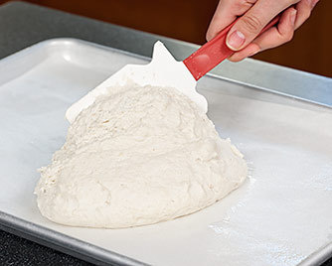
2. Cover with plastic wrap and press into even round with raised edge. To avoid gummy results, prebake crust, then top and bake to finish.
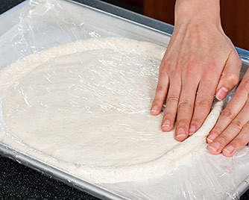

Building Our Own Gluten-Free Flour Blend
When developing our gluten-free pizza recipe, we wanted a wheat-free substitute for all-purpose flour that would work in our pizza dough as well as in cookies, muffins, and cakes. We found that store-bought gluten-free blends perform inconsistently; one product might deliver great cookies but subpar cakes. For that reason, we decided to create our own.
To start, we reviewed how wheat flour works. When hydrated, starch granules in the flour swell, and with the help of mixing or kneading (or sufficient time), the proteins in the flour link up to form long elastic strands called gluten. These strands surround the gelled starch granules, creating a network that enables rise and a sturdy structure. Since no single gluten-free flour or starch performs in this way, a blend was necessary. We found that two flours—white rice flour and brown rice flour—provided the right baseline of protein, starch, and flavor. And since different starches absorb water, swell, and gel at different temperatures and to different degrees, we enlisted two kinds—potato starch and tapioca starch—to create the right amount of chew and structure. Finally, the proteins and sugars in milk powder ensure that baked goods brown properly.
Be aware: A gluten-free flour blend is a complicated mixture, and thus brands aren’t easily interchangeable. It’s best to work with recipes that have been developed around a particular blend.
WHITE RICE FLOUR: Provides a neutral-tasting, refined protein/starch base.
BROWN RICE FLOUR: Supplies proteins that, along with those in the white rice flour, create a network that mimics gluten. Also provides a nutty, wheaty flavor.
POTATO STARCH: Contributes large starch granules that gel at higher temperatures and set to a more extensive, open network when cool, thus providing tenderness.
TAPIOCA STARCH: Provides smaller granules that gel at lower temperatures, forming a more compact network when cool, thus providing chew and elasticity.
MILK POWDER: Contributes proteins that help improve structure and, along with its sugars, undergo the Maillard browning reaction, which leads to more complex flavor.

